 Wanniassa School

Wanniassa Logo***Partners in Learning***

Preschool - Sternberg Crescent Wanniassa Phone: 6205 8055

Junior Campus - Sternberg Crescent Wanniassa Phone: 6205 7566

Senior Campus - Wheeler Crescent Wanniassa Phone: 6205 6200

### Website: [www.wans.act.edu.au](http://www.wans.act.edu.au/) Email: [info@wans.act.edu.au](mailto:info@wans.act.edu.au) Facebook iconWanniassa P-10 School

June Newsletter 2014

| Upcoming Events: **Tuesday 24th June**  Wanniassa School Fair Committee Meeting  Parent Link JC 7pm  **Friday 4th July**  Last Day Term 2  **Monday 21st July**  First Day Term 3  **Sunday 30th November**  Wanniassa School Fair  11am – 3pm Preschool **Friday 20th June**  JC Athletics Carnival 11am Junior Campus **Friday 20th June**  JC Athletics Carnival  **Thursday 3rd July**  JC Reports Sent Home  **Thursday 3rd July**  K – 6 Disco 6:30 – 8:30pm  **Friday 4th July**  Walkathon/Bikeathon  Prize Assembly 2 – 3pm Senior Campus **Thursday 26th June**  Senior Campus Assembly  11:45 - 12:40pm  **Friday 27th June**  Year 8 Trip to Luna Park  **Thursday 3rd July**  SC Reports Posted Home  **Tuesday 29th July**  ICAS English Competition |
| --- |

Principal’s report

Dear Parents & Carers

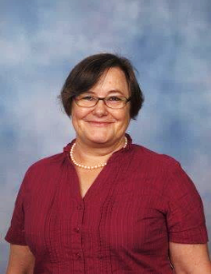

I wish to acknowledge once again Wanniassa School’s amazing, dedicated staff members who continue to demonstrate outstanding expertise and passion in the teaching and care of our students, from Preschool to Year 10. Two long-serving teachers have been profiled in a collection entitled “100 Stories” – **Ms Liz Fearon**, who retired in late January, and **Mrs Margaret Taylor**, Deputy Principal.

Throughout Canberra’s Centenary year a committed project team, in partnership with schools, compiled a book featuring 100 prominent people from the ACT public school system in celebration of Canberra’s Centenary. Each person profiled is recognised for their contribution to enriching the lives of students, schools and the community as a whole. Congratulations and thanks to Liz and Margaret from Wanniassa School for your contributions!

**Canteens** Congratulations to **Ms Natalie Willcox** who has been appointed as the Senior Campus canteen manager. Thanks also to the JC parents and friends who support the Junior Campus. Thanks everyone for your continued strong support for both school canteens, for the student assistance, for all fundraising efforts and the fine collaborative spirit at Wanniassa that makes all the difference to our diverse endeavours.

Yes, we are officially a **Trades Training Centre for Hospitality and Wood Technology/Furniture Construction** (see also below, Students Update). The $8.1 million Tuggeranong Sustainable Learning Trade Training Centre, openedby Senator Zed Seselja on 21 May 2014, will provide a variety of vocational education pathways for students in public secondary schools across the Tuggeranong region. The two colleges and five high schools in Tuggeranong are all part of this exciting initiative and will offer courses in the hospitality, automotive, horticulture and building and construction industries. Wanniassa School will have its celebration early next term - preparing and serving a meal at Café Wanniassa is just the beginning of what our students can/will do to showcase their vocational learning at Wanniassa School In week 5,Wanniassa School’s Enrichment Program continued to draw excellent support with 72 primary students.

In week 5,Wanniassa School’s Enrichment Program continued to draw excellent support with 72 primary students and 30 secondary students participating in two workshops held over two days. The feedback from students was overwhelmingly positive and their feedback on their Wanniassa School experiences was glowing. Thanks to **Ms Stacey Griffiths**, **Ms Penny George**, **Ms Cara Shipp, Ms Meghan Pellow**, **Ms Lisa Hammond** and **Ms Kellie Keeffe** for organising the enthralling Maths/Science & Humanities activities and challenges that were so well received.

Thanks, Parents and families, for your support in completing surveys from time to time. We do get a number of requests for this during the year, and this term has seen an increase in what we are being asked to comment about/respond to about our school’s climate and culture, school improvement initiatives and parental engagement. In term 3 we request your input again regarding overall school satisfaction.

## Students Update

Wanniassa students excel in many ways. We acknowledge their achievements at assemblies, in year group meetings, with postcards, notes of congratulations and media articles. Newsletters also record achievement and excellence.

* The results are in for the Language Perfect World Championships. Wanniassa School answered at total of 35,995questions! Not bad at all. Please congratulate the following students on their efforts and receive a certificate: Chris Johnson, Genevieve Hallett, Rachel Inglis, Sway Measham, Jasmine Irwin & Tristan Launder.
* TASTE 2014 was held on Wednesday 4 June at CIT Restaurant. This was an opportunity for 17 of our students to be part of CIT’s showcasing the training opportunities and career paths that can be achieved in accounting, business, business administration, events, hospitality, hotel management or travel andtourism**.** Thanks to Ms Emily Mumberson for organising the excursion.
* The ACT Cancer Council’s presentation of the2014 Pierre de Courbetin Awardswas held on 20 June. Congratulations toKarly Arranz (Yr 10)who was Wanniassa School’s 2014 recipient!
* Big Picture Program - Internships are an important part of Big Picture; students are experiencing a range of workplace and mentor placements in term 2.
* On the June long weekend Hayley competed at the 2014 National Junior Classic basketball tournament in Melbourne**.** Hayley Mason and the ACT U16 Women’s basketball team played extremely well and came away with a bronze medal.
* The Junior Campus walkathon/bikeathonandPreschool Climbathons have been outstanding successes – thanks to the parents/carers for their support, and to all of the teachers, non-teaching staff and preservice teachers who helped make these events run smoothly.
* Cross Country achievements – congratulations especially to the Gregory girls Jessicaand Kaylee (yr 8) who came 2nd and 3rd I the ACT and will now run in the Nationals in November. Well done to Matthew Jolley (Yr 9) for making the ACT finals. Congratulations to our Junior Campus winners of the **‘**Rugby 7’s Vikings GalaDay’held at Vikings Park on Wednesday 4th June, 2014 – brilliant effort.
* Round 1 of the Sullivan Shield, 13-a-side, rugby league was held at the Kambah Playing Fields. Wanniassa’s year 5/6 team played four twenty minute games and remained undefeated throughout the day. The boys played with pride, displaying exemplary sportsmanship and enthusiasm. Round 2 will be held at the same ovals on June 24. This will be a challenging day as we will be placed in the ‘top pool’ of teams. The winner of the day will represent the Southside in the finals against the Northside some time in term 3.
* The following students graduated with aCertificate II in Businessfrom theFlexible LearningOptions program for IndigenousStudents run by Darren Knight and Clinton Scott-Knight from the Aboriginal Corporation for Sporting and Recreation Authority (ACSRA).Heather Barker-Biles, Quinton Connelly, Nathan Donnelly, Shane Ronning, Ky-Ree Griffen Tamika Lovelock**.** A wonderful achievement.
* Congratulations to Ms Emily Mumberson, the Hospitality students and Oliver Billington on a fantastic and delicious restaurant meal prepared and served recently.  One of the many admiring comments received: The main was superb, the dessert was mouth-watering and the coffee was good as always.  Can’t wait for the next one”.
* Southside Girls Futsal Competition was held on Monday 26th June – congratulations to Oliva Anderson**,** Karly Arranz, Natasha Arioli, Hayley Mason, Caitlan Bartlett, Sabrina Sanchez, Sara Leuii, MadisonWalke**r** for their achievements**.**
* During ACT Public Education Week in May, Senior Campus dancers performed on stage at Westfields Belconnen - well done Dance students and teacher Ms Kate Davoren. Wanniassa School’s amazing singers Saraand Anna Leuii also performed, to wide acclaim.
* Poetry in Action– students interested in performance poetry were entertained in style when three talented poets engaged them in a Poetry workshop recently. We hope they are further encouraged as creative writers and even lyricists.

Principal

Karin Nagorcka

## Nationally Consistent Collection of Data

The Nationally Consistent Collection of Data project collects data from schools about the number of students who require adjustments to participate in education. It will present a national picture of the supports schools provide students. From 2015, this information will be collected in every school across Australian, every year. The purpose of the process is to help governments to target support and resources in schools to help all students reach their potential.

During term 2 2014 all ACT Public Schools will be taking part in the Nationally Consistent Collection of Data (NCCD). Schools will identify students who need adjustments and are identified as meeting a broad definition of disability. This definition is based on the Disability Standards for Education 2005 which is an inclusive definition of what constitutes a disability and does not require a medical or professional diagnosis. If your child currently requires some additional support at school they may be included in the data collection. Examples of the sorts of adjustments and supports a school may provide include:

* Small group literacy and numeracy sessions
* Study lines
* Additional time to complete tasks

A letter will be sent home to families of students that have been identified as requiring adjustments and supports. This letter will outline the process and ask for your permission to include your child in the data collection. No names or personal information is collected as part of the collection process. More information about the NCCD can be found at the Australian Government Department of Education website. <http://education.gov.au/nationally-consistent-collection-data-school-students-disability>

## Australian School Climate Measurement Tool (ASCMT) survey

Dear Parent / Carer

I am writing to request your participation in an important survey about the climate or social environment at this school. The aim is to hear from parents/carers about their experiences as a member of this school community. This survey looks at more areas in detail than the school satisfaction survey, such as relationships with teachers, connection to the school (school identification), and engagement in school life. While we will endeavour to combine the two surveys in the future, it is important for our school improvement process that we receive a strong response to both surveys this year.

Relationships – being valued, respected and listened to in our dealings with others.

Connection – a sense of belonging and connection to the school and what it stands for.

Engagement – investment in and enthusiasm for school

Your responses are extremely useful and valuable in finding out what we do well and where we can improve as a school community.

To access the survey you need to do the following:

1. Use a search engine to find the school web page: [http://www.wans.act.edu.au](http://www.wans.act.edu.au/home)

2. Click on the survey link (or type this code into the search area of the browser)

<https://anupsych.co1.qualtrics.com/SE/?SID=SV_5iQGBNXqsXdKtnL>

If you do not have access to the internet please contact the schools front office for a paper version.

3. Generate your access code following the instructions provided

4. The survey will take 30 minutes to complete

Thank you for your participation.

Karin Nagorcka

# P & C News

## Wanniassa School Fair

The 2014 Wanniassa School Fair has been scheduled for Sunday 30 November 11.00 am – 3.00 pm.

This is a great opportunity for the whole school, Preschool to Year 10, to get together and raise some funds and have a lot of fun. There will be plenty of opportunities to get involved – from helping to co-ordinate the event, working a stall, through to volunteering for a couple of hours on the day.

If you are interested in joining the Fair Committee please come along to our inaugural meeting on **Tuesday 24 June** at 7.00 pm in the Parent Link at the Junior Campus. For further details please contact the Fair Convenor Rebecca Logue on 0413 156 564 or [gtservices@iimetro.com.au](mailto:gtservices@iimetro.com.au)

# Finance News

**Please note that from 1 August 2014, card holders will no longer be able to sign for payments made in person**.  This is part of a banking industry initiative to improve credit card security in Australia, while most overseas countries have already adopted this method of card purchase authorisation.

This also applies to payments made using debit cards and savings account cards. Families will need to use ‘PIN’ authorisation when paying at an EFTPOS terminal. Any transactions without a pin will be declined after that date. However, this does not affect transactions whereby the card number is obtained over the phone or mailed/emailed to the school. If you can’t locate the original PIN you can update the PIN by dropping into your bank with your card and ID.

## School Payments Information *via* our School Web Page - <http://www.wans.act.edu.au/home>

ACT schools are now banking with Westpac.

**Our school’s new BSB is 032-777, and our account number is 001869**

Please ensure you amend your banking records to reflect these changes. If you have the school saved as a beneficiary in your online banking you will need to amend the BSB and account number.

We have implemented a new online payment option, using a Westpac service called Quickweb.

You can go to our school website and make a payment to the school’s bank account. There will be a link that will redirect you to our Westpac Quickweb site. Payments can be made using a credit/debit card, for any school event, or financial contribution.

The information you complete on the form will enable us to accurately identify the funds and the purpose. The terminology used is listed below:

***Family key***; your family’s identifier, first five letters of your last name and the first letter of your first name.eg: ‘Clintb’ for Bill Clinton

***Student key;***  first five letters of the students last name and first letter of his/her first name. eg: ‘Snedda’ for Ann Sneddon

***Fee Codes;*** a unique identifier of the event you are depositing funds for. This will be found on the correspondence sent home with your student. Eg: If it’s a Ski Trip ‘Ski’

The Quickweb payment facility will assist us to accurately identify the sender and the correct ledger for the funds to be receipted against. Receipts for payments can be issued via Westpac Quickweb, but if you require a gift deductible receipt, i.e. payments to a Library Trust Fund, you will need to contact the school.

If you have any queries please don’t hesitate to contact me on: 6205 6200.

Ann Hayres – Finance Officer

# Junior Campus News

## Rainbow Unit

**Climb-a-thon** - Our climbathon was held on June 4th. The children were excited about participating and everyone wore wrist bands to count their 5 laps. Prizes and certificates were presented to all participants. Those who missed out will be given an opportunity to complete their 5 laps on another day and we will present prizes and certificates to them when they have completed their laps.

**Reconciliation Week** - During reconciliation week we put our painted pavers into the bush garden and had morning tea together in the sunshine. We talked with the children about reconciliation being about making friends with everyone. We decided that you could be friends with everyone because there are a lot of things that are similar about all people and that really, everyone is different in some way.

**Blue Unit Assembly -** The Penguins and the Turtles had the opportunity to present The Egg Song at the Blue Unit Assembly. Families were invited to attend and there was a great turn up. The Penguins were also presented with participation ribbons for running in the cross country.

**Athletics Carnival -** The athletics carnival is coming up on Friday, June 20th. Penguins and Turtles will be attending as part of the preschool program. We will send home an invitation to Seahorse and Dolphin families to join us for a short race at about 11.00 am.

Judy Richards, Virginia Fanning and Karen Cooper

## Red Unit News

Red unit has been a very busy place this term! We have been learning about different fairy tales as well as practising our sounds, learning new sight words and doing some wonderful writing. Both grades have been working hard to learn a new digraph each week and we are using these as well as our single sounds to spell words. The kindergarten students are starting to write sentences in their journal books and the year 1s are continuing to work on putting full stops and capital letters into their written work. We are learning lots of new sight words each week and can now use these to help us read short books. We are still busy learning our numbers during maths time as well as the names of all of the shapes, both2D and 3D. It has been wonderful to see how much hard work the students are putting into their learning each and every day!

## Vicki Gough and Sally Gore-Johnson

## Blue Unit News

The second part of this term will see both classes studying a unit of work on history. Year 1 will be investigating the differences between now and 100 years ago with a particular focus on Canberra. Year 2 will be studying the history and importance of historical sites, landmarks and buildings.

Last week we went on an excursion to Lanyon Homestead where the children were able to experience what life was like for 8 year old James Cunningham in 1869. The children toured the homestead, got to see and touch different artefacts and made paper dolls. We also played a number of old fashion games, with croquet being a particular favourite of many children!

We had an excellent time at The Walkathon/Bikeathon on Friday the 6th of June. The children enjoyed playing on the flying foxes and swings and having their sausage sizzle lunch.

Ashley Coutts and Jess Maloney

## Green Unit News

Green Unit students are so excited to have finally started our Maths rotations! The kids have really taken ownership of their learning and are making a serious effort to stay on task and get the most out of Maths time. We are also completing ‘Reflection Journals’ regularly to contemplate the effectiveness of lessons and to think about how we can get the most out of each day at school.

We have begun a whole unit History unit where we are looking at life in Australia prior to 1788 and are even designing our own shelters! We have started Scaffolding Literacy with Mrs Harders and Writers’ Notebook with Ms Lord and are really engaging in some new and exciting ways of reading, writing and spelling.

As always, it is a busy time in Green Unit, but we are still asking that all Green Unit students complete their weekly homework and practice reading at home every day.

## Jess Booth and Tracey Hanson

## Orange Unit News

It’s hard to believe that the end of another term approaches quickly. It has been a busy term, with Year 5 camp and NAPLAN.

Year 5 are back! Camp Cooba was an absolute thrill. New skills were learnt, challenges were passed! They were pushed past their comfort zones and work cooperatively in teams. Highlights varied from student to student, but they all enjoyed getting muddy on the assault course and taking a dive off a cliff – with harness ropes of course!

All of Orange Unit is have ventured into conducting some interesting Science experiments as well as learning about procedure writing. We have been looking at experiments relating to the different properties of solids, liquids and gases. We have also investigated how forces can be exerted by one object on another, through a variety of experiments.

Justan Fuller & Helen Wilson

## Yellow Unit News

In Yellow Unit we have been writing narratives. We started by developing a character on a character placement. We then developed our story using a planning template. We used our peers to give constructive criticism and made the appropriate changes. We are now in the publishing stage of some very entertaining and well written narratives. Our sporting teams have been very successful with our 5/6 Rugby team winning the Vikings 7 aside gala day and the Sullivan Shield Rugby League team went through round 1 undefeated.

Susie Deards and Nick Bond

## Japanese News

In the Japanese room the students in Orange and Yellow Units are working hard to speak and understand sentences in Japanese. They have been working on asking ‘What is your name?’, ‘How old are you?’ and ‘What year are you in?’ We have many more great sentences to learn about, so be sure that you ask one of the students to share their learning with you.

Names and numbers have been the topics for Red, Blue and Green Units. The Red Unit students saw their names in Japanese script for the first time, and were very excited to see how different they look! Green Unit students can now read Japanese numbers up to 10, 000! The Japanese numbering system is quite easy. They also made ‘hundred’s charts’ from puzzle pieces!

Maybury Sensei

## Sport News

Wanniassa students have represented our school in a number of Tuggeranong events this term and we would like to acknowledge their efforts. The activities ranged from girls and boys touch football to cross country, rugby league through to hockey. A special mention and congratulations goes out to Charlotte Mason, who made it through to ACT level where she will be representing her region in Hobart.

Our year 5/6 Rugby Union 7’s Team represented our school on June 4 with passion and pride during the Vikings Rugby Union Gala Day. Many Tuggeranong schools attended the day and the games were all played with great teamwork and sportsmanship. Wanniassa School won their pool games and progressed to the semi-finals. Their success in that match ensured a berth in the grand final where they were successful in winning the game and the tournament. The team was awarded the ‘Winners Trophy’ as well as all team members were given a medallion for their efforts. Caleb Desmet-Whyms achieved special recognition and was awarded a trophy for ‘player of the tournament’.

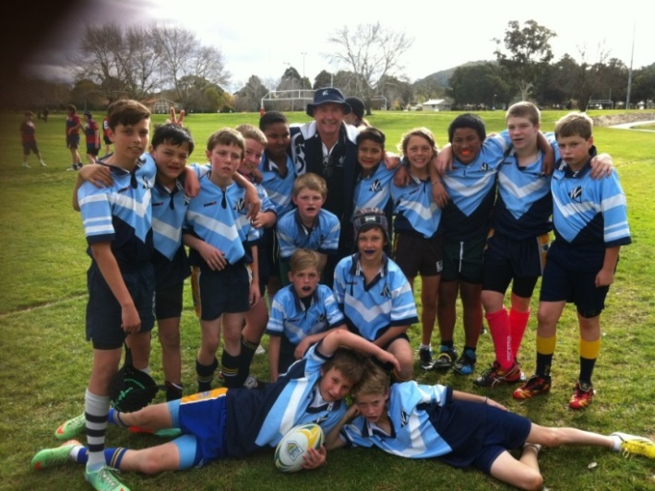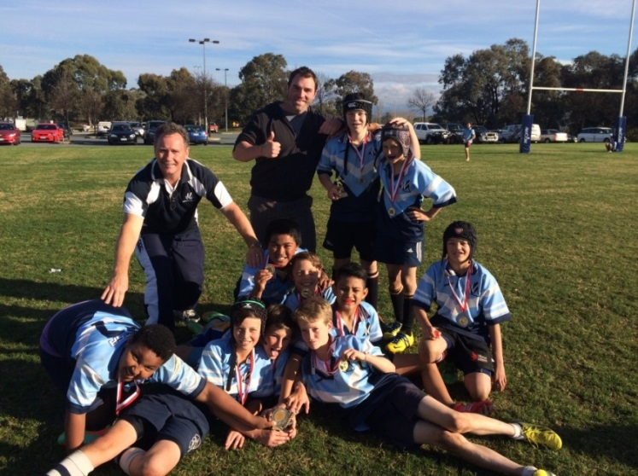Round 1 of the Sullivan Shield, 13-a-side, rugby league was held in week 7 at the Kambah Playing Fields. Wanniassa’s Year 5/6 team played four twenty minute games and remained undefeated throughout the day. The boys played with great team spirit and enthusiasm, displaying exemplary sportsmanship during every match. Round 2 will be held at the same ovals on June 24. This will be a challenging day as the school’s team will be placed in the ‘top pool’ of teams. The winner of the day will represent the Southside in the finals against the Northside some time in term 3.

Greg Pickering

## Library News

**Connect 2 Reading**

**Book Week 2014 – Art & Craft Competition**



“Connect to Reading”

Are you up for this year’s challenge?

Want a great holiday activity?

This year the theme is all about connecting to books and reading so our craft competition is about a book that you have a special connection to.

The challenge is to create a diorama (scene in a box), model or poster of your favourite book or book character.

Because it is about connections, you could use Lego to make a model or make your poster or model look like puzzle pieces joined together.

We will have some GREAT PRIZES AND CERTIFICATES

Entries can be brought into the Library ANYTIME NOW!

MUMS & DADS…it would make a fun holiday activity

* No time for the kids to be bored!!

Please ensure that your entry has your child’s name & class on it.

Happy creating!

Elaine Hine – Librarian

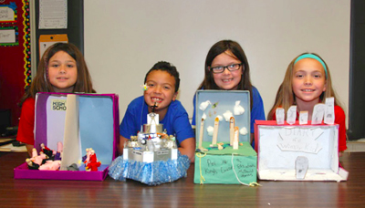

# Senior Campus News

## Pastoral Care

### Pastoral Care Team

**Ann Hill** - Coordinator – 6205 6178

**Trevor Preston** – Youth Support Worker – 6205 7855

**Robert Walls** – School Counsellor (Mon & Tues) – 6205 6179

**Anita Sutherland** – Indigenous Education Officer – 6205 7855

## Mathematics and ICT

On Wednesday and Thursday of Week 5 Wanniassa Senior Campus hosted the second annual Wanniassa Enrichment Program (WEP). This year’s program saw over 100 students, years 4 to 10, from schools across the Tuggeranong Network join with our Gifted and Talented students for a day of interactive and enriching workshops. This year we have students competing from Wanniassa Hills PS, Wanniassa School JC, Namadgi School, Lanyon High, Richardson PS, Bonython PS, Fadden PS, Charles Conder PS and Theodore.

In 2013 we started the program with a mathematics focus, but due to the feedback and popularity of the event we have expanded it to include the Humanities and Science as well. In 2014 students have elected to compete in either the Humanities or the Mathematics / Science stream, which they broke into during the workshop days. For the rest of the term our competing students will be completing a series of online challenges which are designed to extend those students who want to be challenged in their chosen fields.

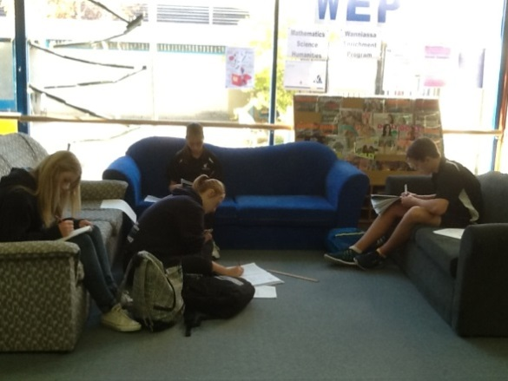If your child is competing in this program, or would like to be considered for next year’s program, please don’t hesitate to contact [Stacey.griffiths@ed.act.edu.au](mailto:Stacey.griffiths@ed.act.edu.au) , [cara-jane.shipp@ed.act.edu.au](mailto:cara-jane.shipp@ed.act.edu.au) or [penny.george@ed.act.edu.au](mailto:penny.george@ed.act.edu.au).

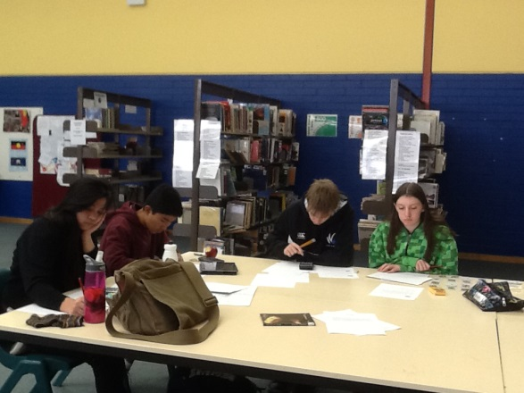

*Senior students from Wanniassa SC, Lanyon High and Namadgi SC completing mathematics challenge questions.*

In ICT news it has been a busy semester for staff and students, with some excellent projects coming out of our ICT classes, the ICT Internship Program (the ICT Sherpas) expanding to include more students and staff heading to Brisbane for the 2014 EduTECH conference.

Anand Banjerie, Mitchell Rogers, Daniel Oshyer and Aaron Marquardt are all heading to Wanniassa Hills Primary Schools every second Thursday to provide ICT support. They are all excited to have this opportunity to put into practice those skills they have been honing during their sessions at school. This is something we are hoping to expand into formal ASBA opportunities for our senior Sherpas with the option of also extending this outreach support group to other primary schools in our feeder network.

David Green and I were lucky enough to head along to the EduTECH conference in Brisbane this year, where we heard from some of the leaders in the ICT and Education fields from across the world. It was enthusing to know that the work our staff and students have been putting into embedding ICT use across our curriculums is linking in so strongly with educational research and new advances in technology. We have such a wide range of ICT options available to our students, when combined with innovative and flexible practices in the classrooms, is placing us at the forefront of ICT practices across ACT schools.

Stacey Griffiths SLC ICT / Mathematics / ICT

## English/History/Geography/Japanese and Indigenous Programs news

The Wanniassa Enrichment Program (WEP) held in Maths/Science/Humanities for Primary and Secondary students of the Tuggeranong Network in Week 5 was a great success with over 100 students participating altogether. I encourage any students interested in extension in English, History or Geography to keep an eye on the Blue staffroom noticeboard for upcoming events and competitions.

Performance Company Poetry in Action performed for 20 English students at the senior campus on 27 May and kept students enthralled.

Thanks very much to Madison Walker and Jacqui Reid in Yr 8 for presenting at our school assembly for Reconciliation Week. We will be celebrating NAIDOC week in Week 10 with:

* Burroinjin, art workshops and cooking workshops
* Gods of Wheat Street screenings
* Literacy and Numeracy activities with Indigenous perspectives
* Guest speakers/performers, including Gary Oakley from the Australian War Memorial to talk about the experiences of Indigenous soldiers at war.
* A parent/community afternoon tea – invitations will be distributed with more information

Finally, congratulations to the 6 Wanniassa School Indigenous students in Yr 9/10 who graduated from the Flexible Learning Options Certificate II in Business. We are looking into ways that we can continue to offer some flexible learning options for senior Indigenous students at school with Darren Knight and Clinton Scott-Knight.

Cara Shipp

Executive Teacher, English/History/Geography/Japanese and Indigenous Programs 6205 6298

[cara-jane.shipp@ed.act.edu.au](mailto:cara-jane.shipp@ed.act.edu.au)

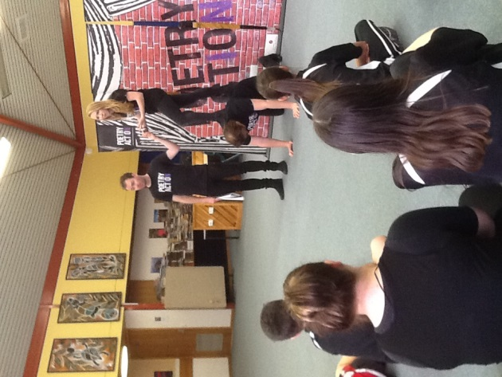

## Japanese News

Our Japanese students on the senior campus participated in the Language Perfect World Championships 2014 held: 19 May – 29 May.  This is an online competition involving more than 1000 schools around the world. The students learn Japanese script and vocabulary online in order to earn points and win prizes. Wanniassa School answered more than 35,000 questions during the competition and placed first in the ACT for the 1-50 students category and 32nd in Australia for the same category.  The following students in particular did very well and deserve to be recognised for their outstanding effort.

|  |  |  |  |
| --- | --- | --- | --- |
| **Award** | **Student** | **Points** | **Class** |
| GoldGold Award | Chris Johnson | 3,085 | 2014 Year 09/10 Japanese - Gastineau |
| BronzeBronze Award | Genevieve Hallett | 1,142 | 2014 Year 09/10 Japanese - Gastineau |
| CreditCredit Award | Rachel Inglis | 889 | 2013 Year 8.1 Japanese - Gastineau |
| CreditCredit Award | Sway Measham | 594 | 2014 Year 07/08 Orange Japanese - Gastineau |
| CreditCredit Award | Jasmine Irwin | 536 | 2013 Year 8.1 Japanese - Gastineau |
| CreditCredit Award | Tristan Launder | 507 | 2013 Year 8.1 Japanese - Gastineau |

Unfortunately the Trivia Night for the Japan Trip had to be cancelled.

Natalie Gastineau

## Literacy News

Writing at Wanniassa continues to be a big focus for us in 2014 with the introduction of the Writer’s Notebook process during our Enrichment sessions.  Students are being exposed to many exciting and interesting ‘seeds’ which form the basis of a writing task. I am delighted to have had many students coming to me to show off the work that they have been producing during these sessions.  I have created a large display to showcase student’s work which is wonderful and fulfilling for students to see their work on display.  It is the hope that the skills that students are developing during these session will transfer into classes, where students will become stronger and more confident writers.

A number of students entered a short story and poem writing competition during Term 2, I am delighted to share that Teagan Crawford and Tea Moma, in year 8, have been selected to have their story and poem published. The girls should be very proud of themselves and we hope it gives them the inspiration to enter the competition again next year.

Kellie Keeffe

Literacy Field Officer

## Real World Learning for the 21st Century

Wanniassa School trialled the Work Studies Curriculum component of the Australian Curriculum in 2013 and we have now been invited to begin stage two and pilot the finalized curriculum. We were asked to present at ACARA to schools from around Australia demonstrating best practice. Wanniassa School is recognized as a leader in community partnerships and engaging students in applied learning outside the classroom.

Big Picture education has a strong foundation of leaving the classroom to learn, finding mentors and internships within the community to develop real applications for students’ learning. Students do not only gain a deeper understanding of their academic pursuits but those less tangible skills such as persistence, resilience, prioritizing, organization, etc. These are important employability skills.

In 2014 we have continued to develop our partnership with the Australian National University and Smith Family to provide students with experiences of further education and positive mentors. We were lucky again to participate in the i-Track online mentoring program and SmArts, music and visual arts program. Strong partnerships are one of the key factors in successful and meaningful learning communities and in the application of academic understandings outlined in the Work Studies curriculum.

This semester Big Picture students have been to a range of work experience placements such as:

* Wall and Floor Tiling - ***Stile Ceramic Tiling***
* Horticulture - ***Yarralumla Nursery***
* Community Services Certificate- ***Youth In The City***
* Sign writing - ***Any Sign***
* Fitness Instructor - ***Define Fitness and Alive Fitness***
* Veterinarian - ***Wanniassa Hills Vet***
* Retail - ***Lincraft, Trade Secret***
* IT - ***Wanniassa School IT support Sherpa program***
* Curator- ***Beaver Gallery***

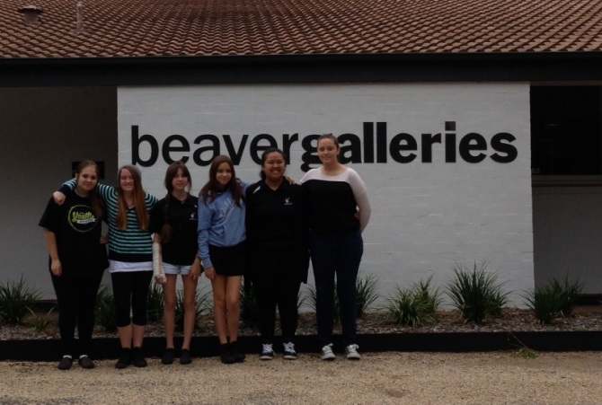Excitingly two Year 10 students, Kaila Mead and Toni Ede, both received Australian Schools Based Apprenticeships in Early Childhood Education from the Education and Training Directorate. Several students are enrolled in Certificate II or III course such as Business and Personal Fitness along with on-line University courses in science, all with the inspiration and intention of broadening students’ opportunities to experience real world environments and be innovative 21st century learners.

# Whole School News

**WINTER FOOD APPEAL**

**St Vincent de Paul Society** (South Tuggeranong)

Donations of non-perishable food would be greatly appreciated, in particular:

* Tinned and packet soups

* Baked beans and tinned spaghetti

* Tinned fruit

* Tinned tuna

* Tinned veggies and tomatoes

* Rice and pasta

* Tea, coffee, sugar

* Weetbix

* 2 minute noodles

* UHT milk

Please buy an extra tin or two at your next shop and help

those struggling through the Canberra winter.

For more information or enquiries please contact

Wendy Napier from Opportunity To Do on 0404 182 494

**Is your child struggling?**

* **Struggling at school? - Not enjoying school?**
* **- Homework trouble - Low confidence /self-esteem**
* *Don’t give up!* ☺

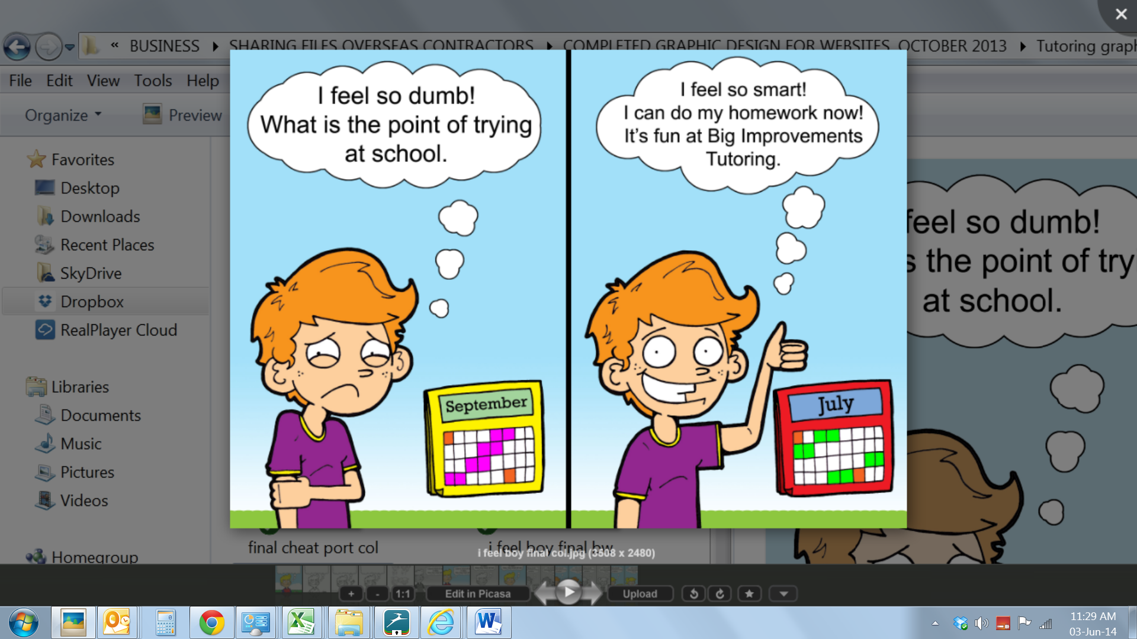



**☺ Make learning fun for your child!**

**☺ No worksheets! No big groups!**

**☺ First session is FREE !**

**(and your child gets a family pass to the movies!)**

**We care… Call 6242 7725 or 0400 447 828**

[**www.bigimprovements.com.au**](http://www.bigimprovements.com.au)