 Wanniassa School

Wanniassa Logo***Partners in Learning***

Preschool - Sternberg Crescent Wanniassa Phone: 6205 8055

Junior Campus - Sternberg Crescent Wanniassa Phone: 6205 7566

Senior Campus - Wheeler Crescent Wanniassa Phone: 6205 6200

### Website: [www.wans.act.edu.au](http://www.wans.act.edu.au/) Email: [info@wans.act.edu.au](mailto:info@wans.act.edu.au) Facebook iconWanniassa P-10 School

August Newsletter 2014

| Upcoming Events:PreschoolJunior Campus **15th August**  Green Unit Assembly  11:30am  **18th - 22nd August**  Book Week  **20th August**  Legend Shield League 7’s  Sydney  Japanese Fun Day  **22nd August**  Book Week Assembly/Dress Up Parade 11:30am  **25th August – 5th September**  Swim & Survive Program K-3  **12th September**  Red Unit Assembly – 11:30am  **19th September**  Learning Journeys 9am-11am  Sydney Holiday Raffle Draw  **30th November**  Wanniassa School Fair  11am – 3pm Senior Campus **19th August – 20th August**  Year 9 Ski Trip  **29th August**  Final day to return all monies and raffle tickets (sold or unsold).  **19th September**  Sydney Holiday Raffle Draw  **30th November**  Wanniassa School Fair  11am – 3pm |
| --- |

Principal’s report

## Photograph of Principal Karin NagorckaDear Parents & Carers

We welcomed our parents and families into the school for **parent/teacher interviews (Junior Campus)** and **3-Way meetings between parent/teachers/students (Senior Campus)** in Week 3. Thank you for continuing to support your child/ren at Wanniassa School as together we partner in learning with each student. Our whole-school approach of knowing our students really well, enriching learning through personalising programs and targeted literacy and numeracy strategies as well as supporting student pathways is achieving desirable educational outcomes across the school.

We warmly invite parents and families to contact the Senior Campus (ph 6205 6200) when **Café Wanniassa** hosts parent morning teas in the near future. You will soon hear about these through your (Senior Campus) child’s Pathways Tutor Group as we enable our Hospitality students to “learn their trade” as part of Wanniassa School’s Trades Training Centre. **Wood Technology** students are also working hard to learn about furniture making and gain competencies in this and related wood projects.

**Wanniassa Preschool** has produced a picture book that provides parents with valuable information and accompanying beautiful pictures about our preschool. A launch was held in Week 3 to celebrate this beautiful creation. Thanks to the Preschool Team for your efforts.

Congratulations to all our Year 7 students who participated in the 2014 Anzac Day Schools’ Awards. They were Highly Commended for “outstanding achievement in commemorating the service and sacrifice of Australia’s servicemen and women. Their teacher, Ms Cara Shipp, also received a certificate in appreciation of her outstanding effort to coordinate the learning activities of our school and in recognition of her valued contribution to commemorating the service and sacrifice of Australia’s servicemen and women”. Well done indeed!

## Staff Update

Congratulationsto Ms Estelle Gillinghamon the birth of her daughter Eloise! Gilly is on maternity leave until the beginning of the 2015 school year. We know she is very much enjoying her new role! Ms Natalie Gastineau is also on maternity leave and Ms Jo Brown is teaching Japanese in her place (Senior Campus).

CongratulationstoMs Sonya Maybury who is now Ms Sonya O’Hara after her recent marriage!

In July, Ms Cara Shipp (SLC)presented a paper at the national ALEA/AATE conference. Her topic was ‘Engaging with Aboriginal & Torres Strait Islander perspectives WILL build strong minds, places and futures’ and it was very well received.

Ms Kate Davoren is on leave in Term 3 (overseas). We welcome Ms Sally-Anne Hegh who is taking her teaching load, and also Ms Jodi Green teaching Maths & Science this semester. Ms Yvonne Masters has returned from 4 weeks’ study leave in the UK energised and enthused about formative assessment and enriching learning and we thank her for sharing her expertise with us. We warmly welcome Ms Kate Conway(classroom teacher) and Mr Kori Plumridge (Youth Support Worker) into the Achievement Centre, a Tuggeranong Network resource located at Wanniassa School. Mr Kim Barham(Building Services Officer) has transferred to Fadden Primary School for Term 3.

## Facility Upgrades

I sincerely thank **Ms Maddie Mackay** our tireless, indefatigable Business Manager, for her sterling work on facility improvements recently for Wanniassa School. As you know, the fence around each campus has made an appreciable difference already. Additionally, it is fantastic to report that the Senior Campus has received upgrades/improvements to the Library, the Music Room, the Canteen area, carpet for corridors, Basketball & Tennis courts upgrades, the graffiti wall (tennis backwall) has been removed and the Kitchen and Wood Technology areas to support Trades Training have been upgraded to industrial requirements. For the Junior Campus we have purchased a storage container to increase available space for furniture and larger items.

## Students Update

Wanniassa students excel in many ways. We acknowledge their achievements at assemblies, in year group meetings, with postcards, notes of congratulations and media articles. Newsletters also record achievement and excellence.

* Congratulations to the Junior Campus Sullivan’s Shield Rugby League team who reached the finals, finishing third. A fantastic effort! The Rugby 9s (Year 7 & 8 students) joined our Rugby 7s (Years 5 & 6 students) to become ACT champions for 2014 – an outstanding effort for Wanniassa School. We wish the Rugby 7s team all the best as they play in Sydney by invitation against regional NSW teams in a state-wide play-off. Thanks parents and families for supporting our players so diligently with transport to games and in full voice at the games.
* On the Junior Campus, the new SRC members were inducted at the Week 2 assembly and outgoing Semester 1 SRC representatives received a certificate of thanks and recognition of service. Year 9 and 10 students interested in school leadership are currently expressing interest in taking on school captains, vice captains and house captains roles in 2015. These will be announced in due course.
* Red and Blue Units(Junior Campus) celebrated 100 Days at school in style recently with a variety of activities.
* NAIDOC Week (end of Term 3 Term 2) was a time of celebration for all students from Preschool to Year 10 and to participate in cultural activities and special events. Thanks to the school’s organisers of the whole-school assembly, guest presenters and the wide-ranging class activities.
* Thank you to all of the hardworking ICT Sherpas on the Senior Campus for your support during Terms 1 & 2,and congratulations – you certainly deserve your certificates recognising the completion of the Wanniassa Information and Communication Technology Internship.

## Community News

Thanks to the **P&C members** who are preparing for another fete at the end of November. All donations and support in whatever form is much appreciated. Thanks too to families and the wider community who are so generously supporting our fundraising efforts to assist the Japan trip (late September), the P&C raffle with fabulous prizes, and other student-directed initiatives to support sports representatives who will soon be competing in the national arena.

**Karin Nagorcka**

**Principal**

## 2014 School Satisfaction Surveys

The 2014 School Satisfaction Surveys will be conducted this term. Parents and carers, school staff and students (in years 5 to 12) will be asked to participate in these important surveys. The survey results will contribute to the school improvement process,which aims to achieve high standards in student learning, innovation and best practice in ACT public schools. The surveys include nationally agreed parent and student items and our 2014 School Board Report will include a summary of our school survey results for these national items. Although the survey is voluntary, we hope you will want to participate. It won’t take much of your time and it will help us understand areas where we are doing a good job and areas for further development. A letter or email about the parent survey will also be sent to you. The key results from the 2013 School Satisfaction Surveys have been published in a brochure which is available at [www.det.act.gov.au](http://www.det.act.gov.au) under publications.

Thank you in anticipation.

**Karin Nagorcka**

**Principal**

## Time to Talk - your thoughts about partnerships between families and schools

Parent engagement in learning and education is all about how families and schools talk to each other, how to bring together learning at home and learning at school, and how families and schools can work together to help our children be the best they can be.

There is very strong evidence that children do better and learn more when families and schools work together as partners.

The ACT Government has partnered with the Australian Research Alliance for Children and Youth (ARACY) to research parent engagement in the ACT and develop a strategy to strengthen parent engagement into the future. An important aspect of this research is talking with families about what parent engagement means to them.

ARACY would like to hear from parents about what they think makes for a good partnership with their child’s school and the things they do to help their children learn.

ARACY has developed a short online survey to gather parental views, beliefs and understandings about parental engagement in schools. The survey will be available on the ACT Government Time to Talk website from 21 July 2014 to 26 September 2014. [www.timetotalk.act.gov.au](http://www.timetotalk.act.gov.au)

# P & C News

## Sydney Holiday Raffle

Thank you very much to the many families who have already returned their sold raffle books.  The response has been fantastic and the P&C very much appreciate your support.  Please note that additional raffle books are still available to be sold and can be collected from the Front Office at both the Junior and Senior Campuses.  Please remember that all monies and raffle tickets (sold or unsold) need to be returned to either Front Office by Friday 29 August 2014.

**Wanniassa School Fair – Sunday 30 November 2014**

Arrangements for the Fair are coming along nicely, with lots of food, entertainment and fun already planned.  Lots of rides for all ages have been booked and we are even expecting a visit from Brumby Jack!

Many people are beginning to ask “What can I do to Help?”

For families who would like to do some volunteer work and help the school, assistance in the following areas would be greatly appreciated.

Donations of:

* Second hand Books/CDs/DVDs
* Plants
* Prizes for Tombola Stall
* Cakes/Slices/Treats (to be delivered on the day)

Volunteers to:

* Work on stalls
* Sign Writers
* Fair Set Up/Clean Up

Do you have your own business/hobby - would you like to put in your own stall at the Fair?  A limited number of stall sites can be rented for a reasonable cost.

Do you know of a business that might be interested in offering sponsorship for the Fair?

For further Fair information or to volunteer your services please contact Rebecca Logue at [gtservices@iimetro.com.au](mailto:gtservices@iimetro.com.au) or 0413 156 564.

Thank you to everyone who has volunteered already.

## ACT Council of P&C Associations



ACT Council of Parents & Citizens Associations

The parent voice on public education

$190 million extra for our schools?

Last year the ACT and federal governments signed a $190 million joint agreement for six years of extra funding for ACT schools following the recommendations of the Gonski review.

This extra funding is now making a difference in our schools. It means more teachers and more resources.

However, the federal government has now announced that it will not fund the final two years of this agreement, the crucial years where two-thirds of the funds were to be delivered.

Not having this funding will make it harder for ACT schools to implement their plans for improving our schools. Those plans include:

• reducing class sizes

• expanding literacy and numeracy programs

• increasing the individual attention and support for students at risk

• providing greater assistance to students with disabilities or special needs.

Please help us tell the federal government that we want our children to have all the resources they need for a high quality education. Visit [www.igiveagonski.com.au](http://www.igiveagonski.com.au/) to find out more about the issue and to add your voice to the call for needs-based funding across Australia.

## Father's Day Stall 5th Sept 2014

A BIG thanks for donations given to Mother's day stall. Are you at all able to make a donation to the Father's Day Stall?

We are looking for;

- Men's Socks

- Rolos (for dynamite!)

- Lollies

- Blocks of Chocolate

- Choc Covered Sultanas or Peanuts

- Mugs

- Toiletries

- Plastic kids shovels

- Clear plastic bags

- Flour

- Brown Sugar

- Choc Chips

- Cans of Condensed Milk

- Any gifts you can think of!

We want to get busy putting these wonderful gifts together so send in your donations ASAP!

Donations can be left at the front office. If you'd like to get involved contact the P&C.

# Finance News

## Friendly Reminder - 2014 Voluntary Contributions

Many thanks if you have already made contributions – *it is very much appreciated!*

A ‘*copy’* of your Family Transaction Statement that you would have received in Term 1 will be mailed out to you this week as a friendly reminder.

Contributions made each year enable us to provide an enriched learning environment for all of our children.

To make a payment you can pay by cash or cheque.  EFTPOS is available at the Front Office at either campus. Alternatively payment can be made directly to the school account via Internet Banking.

*The school account details are:*

Westpac

BSB: 032777

Account number: 001869

OR

You can go to our school website [www.wans.act.edu.au](http://www.wans.act.edu.au) and make a payment to the school’s bank account.  There will be a link that will redirect you to our Westpac Quick website.  Payments can be made using a credit/debit card, for any school even, or financial contribution.

Please identify your payment by including the ‘Student Key name’ and what the payment is (eg. Your childs name is John Smith the ‘Student Key’ would be ‘Smithj VolCon’).

If you have any queries please don’t hesitate to contact me on: 6205 6200.

Ann Hayres – Finance Officer

## Bus School Service Changes for Wanniassa Primary School and Wanniassa Senior School

On Monday 1 September 2014 a new ACTION bus network, including a new school services network, will commence.

Please visit the ACTION website **www.action.act.gov.au** or call the dedicated schools information hotline on **6205 5033** for full details of changes and new school service network routes, maps and start / finish times.

Please note: Although a school service may be unchanged in route and direction, please check the start and finish times.

**WANNIASSA PRIMARY**

## Wanniassa Bus Timetable

## School Service Changes for Wanniassa High

Please visit the ACTION website www.action.act.gov.au or call the dedicated schools information hotline on 6205 5033 for full details of changes and new school service network routes, maps and start / finish times.

Please note: Although a school service may be unchanged in route and direction, please check the start and finish times.

# WANNIASSA HIGH

# Wanniassa Bus timetable

# Junior Campus News

## Rainbow Unit News

Welcome back to Term 3. The children have returned to preschool with enthusiasm and have enjoyed catching up with their friends again. We have a busy term planned with the Book Week dress up day and making dioramas for the library competition, a crazy hair day, performances from Jack and Molly and Learning Journeys. A Term 3 calendar has been sent out so that you can keep the dates on the fridge.

We have planned our transition program with the teachers at the Junior Campus. This year we are extending the number of visits and activities within this program. We are implementing our Buddies program as a part of this and the Year 5 students will buddy up with the pre-schoolers once each fortnight to complete a range of tasks. In this way the preschool children get to know some of the older students and learn that they are there to help and support them when they start primary school.

In Week 6 we will have our photo days and order envelopes will be sent home prior to the day. In Weeks 3 and 5 we are organising dental checks. We hope to see many parents taking advantage of the opportunity to have their children’s teeth checked. A note will come home prior to these dates and you will be able to book a time with the therapists.

Judy Richards, Virginia Fanning and Karen Cooper

## Red Unit News

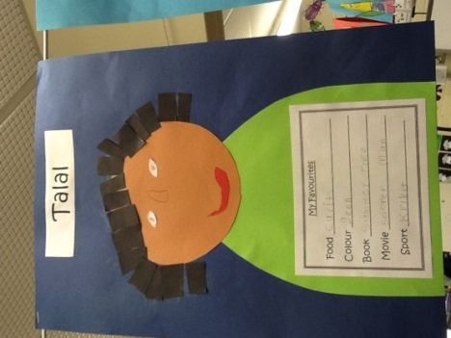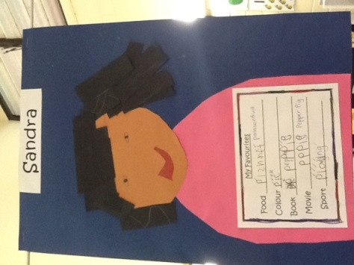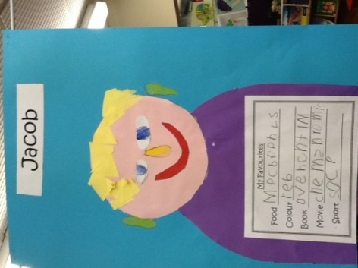We are such big stars in red unit this term that we have our very own red carpet. This is because we are doing a unit about ourselves and what makes each of us special. We have been looking at our favourite things, our families and our own personal history. We have been using all of our knowledge about ourselves to create books for us to share with each other. We have created self-portraits using different craft materials and drawn a picture of all the people in our family. We also bought in an all about me bag that we filled with items from home. We then shared these with the class so that everyone could learn a little more about each other. It has been a fun and busy start to the term and we can’t wait to keep learning more about all the wonderful people in red unit.

## Vicki Gough and Sally Gore-Johnson

## Blue Unit News

This term both classes are studying ‘living things’ in science, with a focus on African animals.   Year 1 is investigation how to compare non-living and living things, are well as life cycles and the features of different animals.   Year 2 is studying how living things grow and change as well as how to categorise different living creatures.   All students will then be researching and sharing facts on African animals of their choice as part of their information report.

Last week we went on an excursion to the Gubur Dhaura Park in Franklin, which is the Ngunnawal name for ‘ochre grounds’.  On our guided walk students were able to learn about how traditional Ngunnawal people interacted with native Canberra plants and animals, as well as the cultural significance of Gubur Dhaura.  We all enjoyed making an ochre artwork with the support of our Ngunnawal guides.

Ashley Coutts and Jess Maloney

## Green Unit News

Green Unit students have had a great start to Term 3. We have continued on with our maths rotations, and have also started literacy rotations each morning. The students are really excited about being able to make choices about their learning and we are seeing all students producing great quality work.

We have started our major geography unit for the year and will be looking at countries in the Asia Pacific region, and countries to which our students have a personal connection with. All students have chosen a county to research independently and will produce a major assignment on their country by the end of term.

Green unit students will be hosting the assembly on Friday 15 August, and we welcome all parents/carers to come along.

## Jess Booth and Tracey Hanson

## Orange Unit News

Orange Unit has hit the ground running this Term. Across the unit, our Literacy and Maths rotations are in full swing. Each week students get to choose when they complete particular rotations and are able to move on to the next as soon as they are finished, all whilst becoming independent learners.

Year 4’s have begun learning about Australia. We are going to be exploring the founders of Australia who came from afar to try and claim this country of ours. We will look at the impact settlers had on the land and to our Aboriginals are the traditional custodians of our land.

The Year 5’s have started the **massive** body wise unit for this term. They will investigate the organs and the different systems that control, protect and regulate our body. All the students are extremely excited about the hands-on experience of dissecting a sheep’s heart and lungs later on in this unit.

Orange Unit is busy preparing for Learning Journey in Week 9. We can’t wait to show everyone how far we have come this term. See you all then!

Justan Fuller & Helen Wilson

## Yellow Unit News

Yellow Unit have commenced their Literacy Rotations. These rotations run on a fortnightly cycle and cover all areas of Literacy such as spelling, grammar, reading, genre writing and handwriting. The children work independently through the program and select the order of their activities. They also book into ‘Masterclasses’ with the unit teachers for explicit teaching. The children are demonstrating independence and a focus on task completion.

Our Unit homework is also now based on a fortnightly cycle with mini projects and research assignments being part of it. The homework will be sent out on all even Mondays and to be returned on the next odd week Friday.

Susie Deards and Nick Bond

## Japanese News

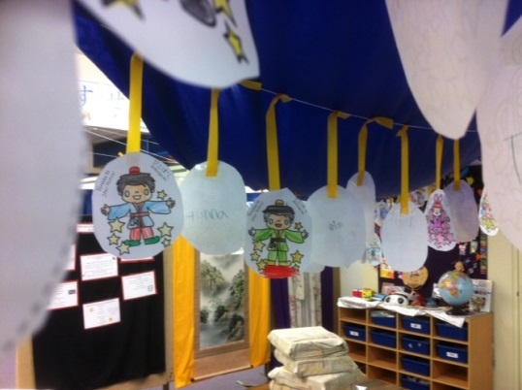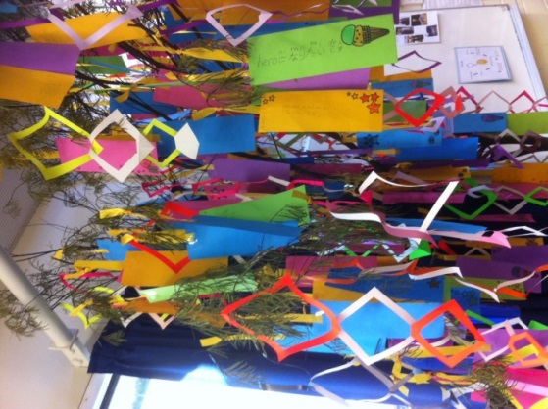We started the term in the Japanese room with the legend of Tanabata, (star festival). The story goes that the star princess and the cow herder fell in love but neglected their jobs, so they were kept apart. They were only allowed to see each other if the sky was clear once a year on the 7th day of the 7th month. In the past people in Japan would make wishes for a clear night. These days the wishes are more about personal goals and hopes for the future. All of the students wrote their wishes and hung them up in the hope that they might come true. What would you have wished for?

O’Hara Sensei

## Sports News

Week three’s assembly saw our students receive their first, second and third place ribbons for their efforts at our Athletics Carnival. The overall individual points tally was a close contest with Matthew Levika and Rylee Cousins-Foster becoming our 2014 Boys and Girls Athletics Champions. Our house winner for 2014 was announced and Namadgi cheered loudly as their captains proudly held the perpetual trophy up high. In week four this term we have around thirty students representing Wanniassa School at the Tuggeranong Athletics Carnival at the AIS. The school and community would like to we wish them all the best in their events.

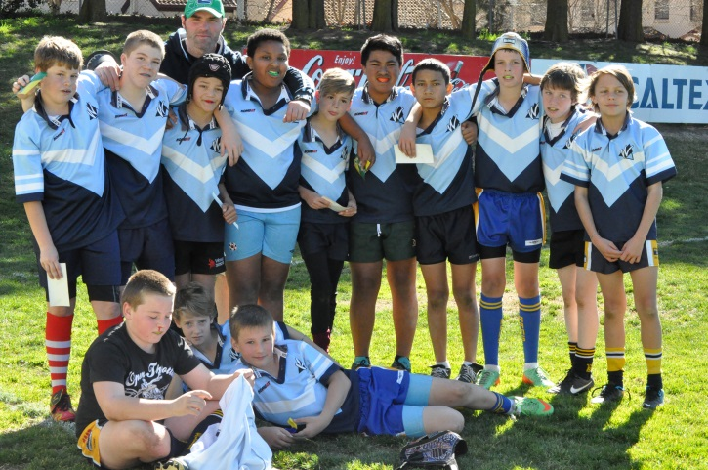Our 2014 5/6 Rugby League team side competed in the Sullivan Shield Finals in week three at the Raiders ground in Holt last Thursday. On the day the boys needed to play two games prior to the final against Marist followed by Queanbeyan Primary. They won both games and proceeded to play off for the Shield Final. Unfortunately they lost their finals game against St John the Apostle Primary School however they played in the best spirit of the game and never gave up. The boys competed in a number of rounds during this tournament and finished first in the Southside competition and third overall in the ACT schools competition.

The Girls League Tag competition will be held on Thursday, week four and Mr Bond has been training the Wanniassa School team for a number of weeks. The girls will be competing against numerous Southside school teams at the Kambah Ovals on the day. This will decide which school/s will represent their region against the Northside representatives on date to be announced.

Wanniassa School’s victorious Rugby League 7’s side has been invited to represent their region at the ‘Legends Shield Finals’ tournament on Wednesday, August 20 in Sydney. This is an honour for our team and school and a fantastic opportunity for the boys to play against the best teams in NSW. The day will consist of pooled divisions followed by the finals and presentations. Congratulations on getting to this representative point and we look forward to hearing all the reports on your return.

Greg Pickering

## Cartoon picture of children sitting listening to headphonesLibrary News

**Time to Talk - your thoughts about partnerships between families and schools**

Parent engagement in learning and education is all about how families and schools talk to each other, how to bring together learning at home and learning at school, and how families and schools can work together to help our children be the best they can be.

There is very strong evidence that children do better and learn more when families and schools work together as partners.

The ACT Government has partnered with the Australian Research Alliance for Children and Youth (ARACY) to research parent engagement in the ACT and develop a strategy to strengthen parent engagement into the future. An important aspect of this research is talking with families about what parent engagement means to them.

ARACY would like to hear from parents about what they think makes for a good partnership with their child’s school and the things they do to help their children learn.

ARACY has developed a short online survey to gather parental views, beliefs and understandings about parental engagement in schools. The survey will be available on the ACT Government Time to Talk website from 21 July 2014 to 26 September 2014. [www.timetotalk.act.gov.au](http://www.timetotalk.act.gov.au)

“Connect to Reading”

Book Week Events

(Mon 18 August – Friday 22 August)

* **Book Week Performance**

Book Week will get off to an early start this year in Week 3.

Once again our students will be treated to an engaging, interactive performance by the Tony Bones Entertainment Company. The performance incorporates musical theatre, slapstick, puppetry and a broad array of comedy.

The performance will be based on one of the short listed picture books for this year called “The Windy Farm” by Doug MacLeod.

The school is generously covering the cost of this performance for all students.

* **Writing Workshops**

We are very lucky to be able to offer our students, from Kinder to Year 6, writing workshops during Book Week run by author Cameron Stelzer. He will spend the day at Wanniassa on Monday 25 August.

Cameron has written the “Stroogle” series of picture books and a chapter book series called the “Pie Rats”.

His presentations will offer students an engaging and informative behind-the-scenes look at creating a novel or picture book. While with our older students Cameron will run a workshop that aims to enhance their writing skills.

There is also an opportunity to purchase signed copies of Cameron’s books at special prices – a separate flyer about this is being sent home.

* **Book Week Assembly and dress-up parade**

Our Book Week dress-up assembly will take place on the Friday of Week 5 - Friday 22 August at 11.30am. It is shaping up to be another big one with several student performances.

Looking forward to seeing all the different the costumes for the parade this year!

* **Doing Things Together Day**

On Tuesday 19 August students will form multi age groups to take part in a number of fun and exciting activities run by teachers around the school. These activities may be book-based but will also have a mathematical element to them as we combine Book Week and Literacy & Numeracy Week.

* **Special lunchtime activities every day in the Library**

Quizzes, competitions and craft

Happy reading!

Elaine Hine (Teacher-Librarian)

Elaine Hine – Librarian

# Senior Campus News

## Pastoral Care

### Pastoral Care Team

**Ann Hill** - Coordinator – 6205 6178

**Trevor Preston** – Youth Support Worker – 6205 7855

**Robert Walls** – School Counsellor (Mon & Tues) – 6205 6179

**Anita Sutherland** – Indigenous Education Officer – 6205 7855

## Technology News

Technology at Wanniassa School has enabled students to create a range of rewarding projects in wood work, metal work and food technology, while gaining a valuable understanding of the practical nature of these subjects.

Semester 1 began with Year 7/8 students learning fundamental workshop skills through the construction of a Wooden Whistle, a challenging Timber Puzzle, a Wall Mirror and finished with a Chopping Board. Year 7/8 metal work students also familiarised themselves with metal working processes and were able to design and build their own SportsTrophy, Wall *Clock* and a wide range of sheet metal Ornamental Animals. Together, both classes were able to learn workshop skills while exploring the creative possibilities in the technology department.

While the school’s kitchen was being refurbished, Food Technology students were able to overcome the challenge of not having practical classes by studying the different foods of the world and analysing the components of a recipe.

Many students were able to bring prior workshop knowledge and experience to Year 9/10 classes, having studied wood or metal work in previous years. In 9/10 wood work, a particular stand out project was the Timber Step Ladder.Thisprojectrequired students to interpret technical drawings, and construct a functional step ladder based on the information provided. Throughout this project, students were challenged to accurately use hand and machine tools, while working together to overcome workshop challenges. In metal work, Year 9/10 student fabricated a sheet metal **Carr**y B*ox* while learning to appreciate the value of accuracy in marking out. Students also had the opportunity to learn about MIG and Oxy/Acetylene welding in preparation for the current 44 Gallon Drumproject.

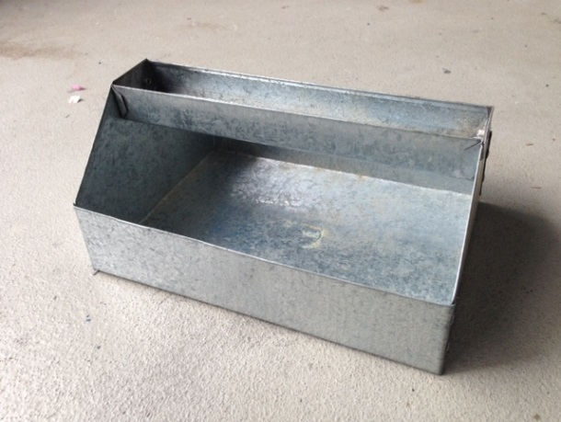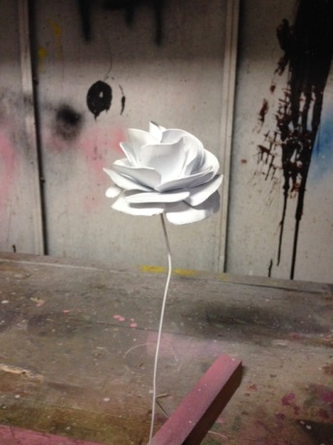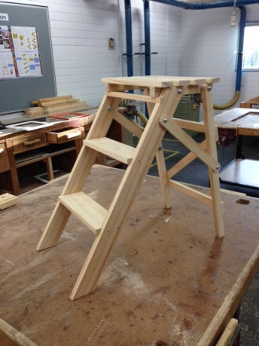I look forward to the continued production of quality student projects in Technology at Wanniassa School.

Oliver Billington - Wood and Metal work Teacher

## English/History/Geography/Japanese News

This semester we welcome Jo Brown in Japanese, while Ms Gastineau is on maternity leave. Jo is continuing to promote the Japan trip and assist students in their preparation for this fantastic opportunity.

In Week 5, we have a visit for senior students to the War Memorial for a special production about the Vietnam War. Places are limited so please remind your student to get their note signed and returned quickly to secure their place.

English students continue to have the opportunity to boost their grades by participating in the Wide Reading Program – students should see their English teacher for further information.

Cara Shipp

Executive Teacher, English/History/Geography/Japanese and Indigenous programs

6205 6298

[Cara-jane.shipp@ed.act.edu.au](mailto:Cara-jane.shipp@ed.act.edu.au)

## Indigenous News

## Basketball

Shadows Basketball Club held their first training / try-out session on Sunday 10 August at Tuggeranong Basketball Stadium.

As part of their development goals they wish to make basketball accessible to Indigenous and non-Indigenous children in the Tuggeranong area. They would like to assist in covering some of the costs associated for players (fees/uniforms) and welcome any additional / new players to attend.  
  
If you are interested and missed out on the first try out, please contact Dion Devow on the details below.

Dion Devow  
Shadows Basketball Club  
0423392210

## Hospitality Apprenticeships

Year 10 Indigenous students interested in completing an Australian School Base Apprenticeship in Hospitality should see Miss Shipp for more information. An application form and resume must be submitted to REAL Community as soon as possible.

## Yalbalinga ANU Camp

The annual camp for Year 9-10 Indigenous students to find out about university life is on again in December. We are in the process of applying for student places on this camp, which will be held in December.

## AIME Mentoring

The AIME mentoring program for Year 9-10 Indigenous students allows opportunities for students to enter a mentoring relationship with Indigenous role models who are in CIT/University further study. Several activities days will be held over this semester and the students attended their first session in Week 2 (30 July). If your student is not already part of the program and is interested, please encourage them to see Miss Shipp or Anita Sutherland.

## Bell Shakespeare Project

We have an Indigenous filmmaker, Richard Jameson of Wirrim Films, working with Indigenous students in Year 8-9 on a film production documenting the school’s Bell Shakespeare performance. They will be creating a short film showing the Shakespeare group’s progress through rehearsals over the semester, culminating in their first step on to the stage on performance night in November.

## Promoting Student Well-Being @ Wanniassa School

Big Picture at Wanniassa School promotes students to pursue their personal interests and passions. So for this year I have researched serotonin and depression including electro convulsive therapy. Following this I wanted to do something more upbeat and interactive but still connected to mental health. Art Therapy combined my interest in mental illness, well-being and my love for art.

Art Therapy is a form of psychotherapy involving the encouragement of free self-expression through painting or drawing to improve mental and emotional well-being.

[](http://patternoftheday.files.wordpress.com/2008/03/fruitmandala.png)I researched different Art Therapy techniques and activities and had teachers implement them in to different classroom environments, this let students experience an Art therapy exercise and taught them how Art Therapy helps with positive mental health and well-being.

One of the exercises the students tried was the “Mandala” which is an intricate pattern that lets the brain relax and access the subconscious to either resolve problems someone is facing or release stressors they may have been unaware that they were hanging on to.

I am currently in the process of creating videos for teachers to use during enrichment classes to give students more exposure to Art Therapy and Mental Health.

By Maddie McQualter

# Whole School News

Summer has never been more fun and healthier for girls and boys with the upcoming Junior Summer Competition.

Running over nine thrilling weeks, starting the week of Monday, 13 October.

Children can begin playing competitive touch football from Kindergarten through to year 10.

Please see attached Jpeg file.

Or

A brief description if possible.

**Touch Football ACT Junior Competition**

Leave weekends Free!

Starts October, 2014

Resister: acttouch.com.au

Contact: Mark Moro

Phone: 6212 2880

Email: [mark.moro@acttouch.com.au](mailto:mark.moro@acttouch.com.au)

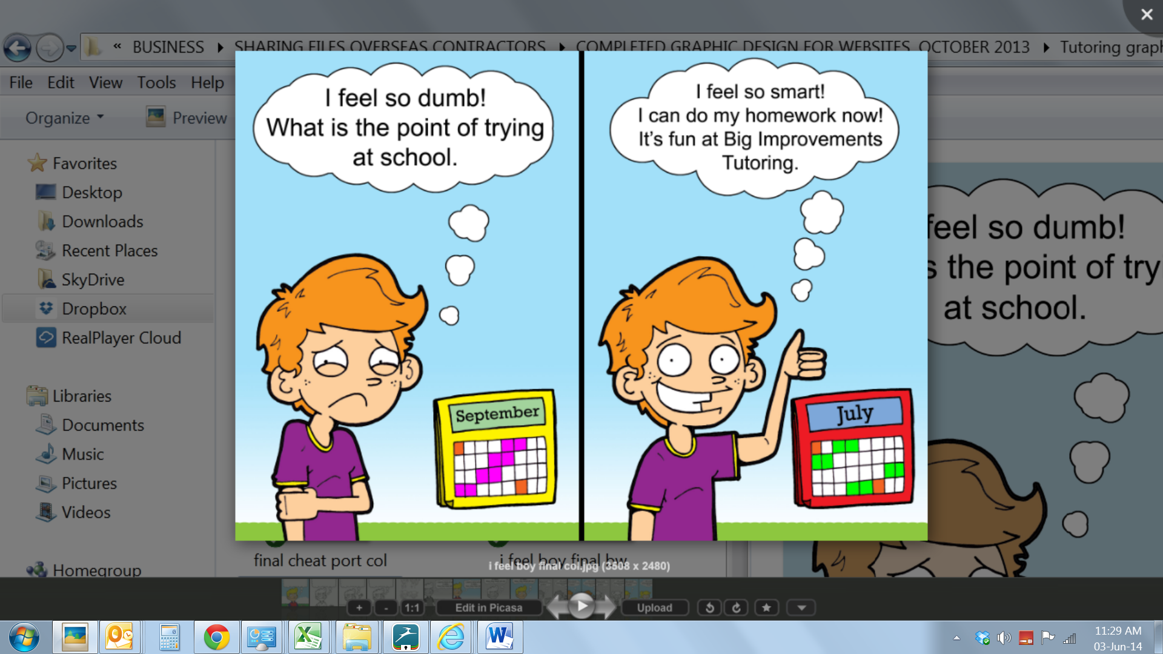



**☺ Make learning fun for your child!**

**☺ No worksheets! No big groups!**

**☺ First session is FREE !**

**(and your child gets a family pass to the movies!)**

**We care… Call 6242 7725 or 0400 447 828**

[**www.bigimprovements.com.au**](http://www.bigimprovements.com.au)



**What:** Science in ACTion

**Where:** Australian National University – Melville Hall (off University Ave)

**When:** Sat 16th Aug**,** 10am – 4pm

**Cost?** FREE!

Explore 3D printing, aircraft design, fossils, parasites, cutting edge IT and so much more.

Hear from artists, cartoonists, researchers, authors, climate scientists and see some explosive science shows.

The littlest members of the family will love Shelly the Snail, exciting science shows with curious puppets, face painting and our free giveaways.

Don’t miss these special Science in ACTion events!

* **10am - 12pm** - meet the AFP detector dogs and talk with their handlers.
* **1pm** – Hear about what it’s like to live in space with astronaut Rick Hieb
* **12pm and 3pm** – Explosive science shows with Science ShowOffs Graham Walker

This is just the start of what's on offer throughout National Science Week - Australia’s largest celebration of science! Visit [scienceweek.net.au](http://scienceweek.net.au) for details of all our events. Or stay up to date by following us on [facebook.com/ScienceWeekACT](http://facebook.com/ScienceWeekACT) or @nswk_ACT on Twitter.