 Wanniassa School

Wanniassa Logo

*A quality education in a caring environment.*

Preschool - Sternberg Crescent Wanniassa Phone: 6205 8055

Junior Campus - Sternberg Crescent Wanniassa Phone: 6205 7566

Senior Campus - Wheeler Crescent Wanniassa Phone: 6205 6200

### Website: [www.wans.act.edu.au](http://www.wans.act.edu.au/) Email: [info@wans.act.edu.au](mailto:info@wans.act.edu.au) Facebook iconWanniassa P-10 School

May Newsletter 2015

| Upcoming Events:Preschool27th MayClimbathon/shared lunch23rd JuneP & C meetingJunior Campus21-22 May Year 5/6 Camp Cooba  **25 May**  JC School Photo Day  **29 May**  Walkathon/Bikeathon  **5 June**  Yellow Unit Assembly  11:30am  **12 June**  Athletics Carnival Senior Campus **Every Wednesday**  3:15-4:30 Ganbra Homework Club  **Every Thursday**  Junction Group  **Every Thursday**  3:15-4:30 ANU Homework Club  **26-28 May**  Gulaga Camp  **Whole School**  **2 June & 16 June**  Café Wanniassa |
| --- |

**Principal’s report**

**Dear Parents and Carers**

I have been most impressed with Wanniassa School since the first day I walked in at the beginning of this term. The teachers and non-teaching staff are welcoming, enthusiastic and dedicated to their work with students. The students are friendly and proud of their school and their work. It is such a privilege to be leading a learning community that driving success, ambition and high expectations in all of our students. I have also been welcomed by the members of the parent community that I have met and look forward to working further with you to ensure success for all students. If you too find this school as inspiring as I do please join with me in promoting this quality education in a caring environment to neighbours and all members of the community to make the choice to send their children to Wanniassa P to 10 School. Our open morning/night was on Monday 18 May and a great success. Please help us spread the work about how great our school really is.

Shane Gorman

Principal

**Finance News**

**Voluntary Contributions / Family Transaction Statements**

At Wanniassa School, we deeply appreciate the valuable support of our school community. Your voluntary contributions made each year enable us to provide an enriched learning environment for all of our children.

Your Family Transaction Statements were posted to you in Week 3. Attached will be information on various ways of paying your Voluntary Contributions. Eg: QuickWeb (the online payment service which will enable families/communities to make payment via a secure portal on you school’s website www.wans.at.edu.au) OR Visa/MasterCard credit or debit card (Bank: Westpac, Acc name: Wanniassa School Management Account, BSB: 032777, Account Number: 001869).

Please remember we also accept cash, cheque, credit card and EFTPOS payments through the Front Offices of both campuses!

Ann Hayres – Finance Officer

**Sick Bay**

If Students are unwell they are sent to sick bay with a note from their Teacher. The Front Office Staff will contact parents/carers if necessary. As we have Duty of Care whilst the students are at school we request that Students DO NOT contact parents themselves, but wait for us to call on their behalf. If your child contacts you asking if they can go home sick, ask them to get a note from their teacher to go to sick bay and the Office Staff will then contact you. Thank you in advance for your support.

**Student absences**

If your student is absent, due to illness or leave, or needs to attend an appointment during the day, please phone the Front Office on 6205 6200 for the Senior Campus and 6205 7566 for the Junior Campus and Pre-School and leave a message or email: [info@wans.act.edu.au](mailto:info@wans.act.edu.au). Please remember to include the student’s full name, roll group and reason for absence (ie. sick, late or on leave) as well as your contact details.

**Excursion Acquittals 2015**



# P & C News

**Mother’s Day Stall**

Thank you very much to everyone who donated gifts and purchased gifts at the Mother’s Day stall.

The stall was a great success which raised valuable funds for the school and the younger children especially enjoyed buying a gift for their Mum.

# Junior Campus News

## Rainbow Unit News

Our focus is this term revolves around helping children to establish strong and positive self-identities. Our ‘All About Me’ posters were an introduction to this body of work as families mould and shape our perceptions of ourselves, our beliefs and values. Over the term, we will be looking at our cultural identities, with a strong focus on Aboriginal and Torres Strait Islander culture, Australian culture, landscapes, animals and literature. We will then begin looking at the many different countries and cultures that make up the families of our preschool community. We are inviting families to share their stories with us as we work towards building a strong, inclusive preschool community.

As a way to build strong links between home and school, our class teddies - Pete, Declan and Tommy - have begun going home with students for sleepovers. The idea is that parents write a short story about their child’s time with their take home teddy and then return the teddy to school the next day. The child then gets to share their story with their classmates, developing oral language skills and confidence.

Our fundraising team has been hard at work, organising and running the Mother’s Day stalls for us. The children enjoyed visiting the stall and selecting their special gift. Many thanks too, to the parent helpers who manned the stalls on the day. Our preschool Climb-a-thon will be held on Wednesday 27th May. Come along and cheer on our pre-schoolers and stay for a shared lunch!

Karen Cooper and Virginia Fanning

**Red Unit News**

Welcome back to Term 2. Red Unit has had a big change and is now the ‘World of Books’. To enter our special world you must get through the secret bookshelf and once inside you can see all kinds of our favourite book characters. We have been reading many of the most popular children’s books including ‘The very hungry caterpillar’, ‘Where is the Green sheep?’ and ‘The Rainbow fish’ and completing reading and writing activities about each one. The students have also been working hard with their sounds to start spelling words and are even writing sentences in their journals. We have also started taking our home reading books home and are very excited to start guided reading groups next week. We are looking forward to a wonderful term of learning together.

## Vicki Gough and Sally Gore-Johnson

## Green Unit News

## This term both classes have started a unit of work on History. We will be investigating the differences between now and 100 years ago with a particular focus on Canberra. Students will be encouraged to ask their extended families about the past and life when their family members were young and will be given opportunities to share what they have learnt with the Unit.

## Once a week students have been using the iPads to access the Reading Eggs program. This program aims to improve reading and spelling skills and is able to be used online at home - http://readingeggs.com.au/login/. Students use their Mathletics username and password to gain access.

As always, it is a busy time in Green Unit, but we are still asking that all students complete their weekly homework and practice reading at home every day.

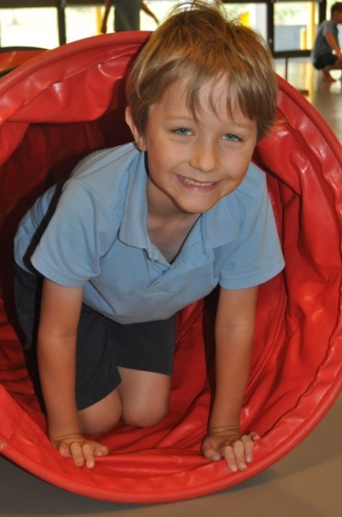

Ashley Coutts and Hayley Eaton

## Blue Unit News

We are so very proud of the Year 3’s for their wonderful effort in their first ever NAPLAN testing. They demonstrated all of the Wanniassa Values and really pushed themselves to do their best. Great job guys!

Our literacy focus for Term 2 will now be Information Reports. We will be examining what they are, when we use them, how we find the information and how an information report is constructed.

We are very excited about the school photos happening in week 5 – and ask that you please ensure your child wears full school uniform to school on this day, and has returned their order envelope if you would like to purchase the photographs.

The annual Wanniassa Bike-a-thon/Walkathon will be held on Friday week 5. Don’t forget to return your permission notes.

Another exciting event happening this term in Blue Unit is our History excursion to the National Library. This is planned for Thursday 4th June and will incorporate attending a performance at the Library with a bus tour of some of Canberra’s major landmarks. Permission notes will be sent home soon!

Christina Bowman, Tracey Hanson & Jessica Booth

## Orange Unit News

Congratulations to all the Year 5’s that completed NAPLAN. All students worked extremely hard and continued to display one of our most important school values of ‘doing your best’.

Orange Unit has been focusing on their persuasive skills in exposition writing. Watch out at home, some of these skills may be used on you!

Students are beginning to present their Geography PowerPoints to the unit. All students are looking forward to being immersed in the rich information about the countries being presented.

Year 5’s are currently realising how cold it can get at Camp Cooba. They will be trying their luck with archery, abseiling, rock climbing and will learn how important it is to work as a team on the assault course. We look forward to hearing all about it and seeing all the muddy pictures when they get back.

Helen Wilson and Rachel Ennis

## Yellow Unit News

Yellow Unit would like to welcome Miss Veronica Noone. She is the new teacher of 5P for the remainder of the term. Miss Noone is very excited to be part of this great school while Mr Greg Pickering is acting School Leader C.

Cooperative Reading commences in Yellow Unit in week 5. During this program the children will engage in books in a deeper level than they have before. The will read, discuss and reflect upon texts which will foster a greater comprehension and understanding of story features.

Congratulations to our year 5 students for their completion of NAPLAN.

Many Yellow Unit students have been selected to represent Tuggeranong teams in both team and individual sport. Wanniassa has a proud tradition of sporting excellence and I would like to acknowledge their efforts and sportsmanship both on and off the field.

Nick Bond and Greg Pickering

## Library News

We are back into a busy Term 2 in the library with students in Preschool, Kinder and Year 1 investigating the parts of a book, book care, choosing suitable books to borrow and fiction and non-fiction texts.

Year 2 and 3 are currently developing a class book each called “Animals should ABSOLUTELY not borrow library books”, which looks at book care and will be shared with the students in Preschool, Red Unit and Green Unit. Year 2 and 3 will also be looking at text conventions in fiction and non-fiction and how to use Oliver Library to search the book catalogue and browse and borrow ebooks.

Speaking of ebooks, did you know that all students and their families can access a huge range of ebooks in our school catalogue at any time at school or at home through the digital backpack?!

If you are interested in finding out more about accessing ebooks please let Mrs Byrne know.

**National Reading Month**

Did you know that May is National Reading Month? Now in its 19th year this special month is designed to get more kids reading with their families. Research shows that family reading time is one of the BEST ways to grow a child’s interest in the wonderful world of books. Reading role models and shared reading time are critical to a child’s learning and literacy development. Kids who read, succeed! In the library this month we will be promoting lots of opportunities for children to borrow books to share with family at home. Don’t forget, families are welcome in the library as well before and after school on Tuesdays, Wednesdays and Thursdays and can set up a membership to borrow.

Happy reading!

Amy Byrne - Teacher Librarian

## Japanese News

**Konnichiwa (Hello/Good Afternoon)**,

K-6 students at Wanniassa have been celebrating Kodomo no hi (Children’s Day). In Japan Children’s Day is on the 5th of May each year. Families create koi nobori (carp streamers) displays to decorate their homes. The koi nobori represent members of their families. Koi are considered very strong and determined fish, so are a symbol for hope that children can overcome obstacles in their lives as they grow.



Arigatou Gozaimasu

(Thank you very much)

Poulakis Sensei

**Chaplain’s Corner**

Welcome back to everyone. Some parents new to the school may not be aware that Wanniassa School has a school chaplain based on the Junior Campus. I am at school on Thursday and Friday each week in term time.

On Fridays I run a Breakfast Club in the Link Room with the help of students and volunteers from the community. It begins at 8.30 am and is open to all students on the Junior Campus. Parents like the fact that it is free. Students enjoy the hot Milo and being inside on a cold morning. You are welcome to come with your child and help them settle in to our way of doing things. If you want to volunteer to help with cleaning up afterwards, that would also be much appreciated! During lunchtimes there is space for sixteen children at a time to come into the Link and enjoy different activities. There are board games, Lego and play dough. This term, I plan to teach some students to knit, so any donations of knitting wool are welcome. You can drop them into the Link Room, send them with your child, or leave them at the front office.

During the day, I visit classes and spend some time with the children in that class. I am also available if parents wish to chat with me. I can be contacted through the front office.

Christine Hosking

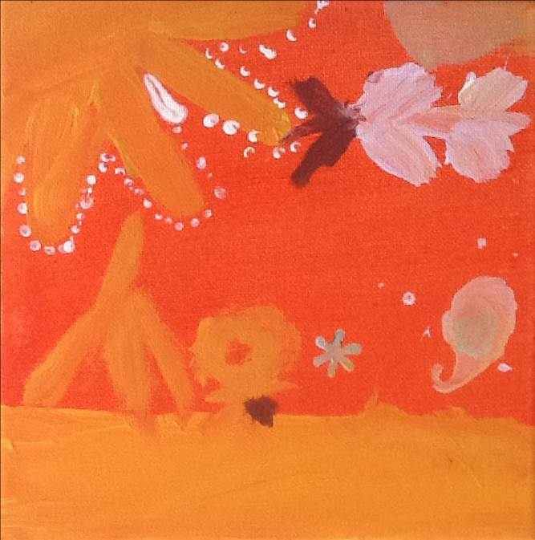

**JUNIOR CAMPUS INVITATION: ABORIGINAL**

**AND TORRES STRAIT ISLANDER STUDENTS & PARENTS**

**LUNCH AND A YARN**

Come and have lunch and a yarn with us about your student’s strengths and how they can be developed at school.

We will be introducing the ***Engoori*** way of discussion.

We want to make sure all our kids are strong, smart and deadly!

DATE: Tuesday 16 June (week 8), 1.30-3pm, Junior Campus, K-3

Tuesday 23 June (week 9), 1.30-3pm, Junior Campus, 4-6

With: Anita Sutherland, Cara Shipp and Michelle Lord

Cara Shipp - Executive Teacher English/History/Geography/Japanese and Indigenous Programs, Senior Campus

Senior Campus News

## Pastoral Care

### Pastoral Care Team

### Ann Hill - Coordinator – 6205 6178

**Trevor Preston** – Youth Support Worker – 6205 7855

**Sue Schulz** – School Psychologist – 6205 6179

**Anita Sutherland** – Indigenous Education Officer – 6205 7855

**Oztag and Touch Football Championships**

Over the last two weeks both Nick Keech and I have had the pleasure of coaching over 30 matches of football and I can honestly say we loved every match minute. Our students were exceptional competitors and played to the best of their ability every game displaying outstanding sportsmanship and leadership.

Oztag was held on both the 4th and 6th of May with most of our competitors backing up for the Touch Round Robin on the 7th May. The Senior Boys had a difficult draw but held their own. With some strong individual plays and strong team structure the boys played to their strengths but unfortunately they were unsuccessful to make it through to the semis (I personally think they were warming up for the Touch Football Carnival!!)  The Junior Boys came together as a team in their third game with some individual plays through the centre and some outstanding last minute tags. Our boys made it through the semi-finals but unfortunately lost the game.

The Senior Girls worked hard in each game, improving in their defence and set plays. Our attack on the line developed as the day went on and our growth and improvement over each game was amazing. The girls also had a difficult draw and were also unsuccessful in reaching the semi-finals.

Oztag offered the platform for our teams to come together and refine our skills, these were great days and set the tone for what was coming next!!

Later that same week the three teams competed in the ACT Touch Football Southside Competition. The Senior Girls side improved throughout the day and had some great results against very good opposition. Unfortunately the girls narrowly missed out on playing semi-finals but they displayed outstanding sportsmanship and represented Wanniassa School proudly.

The Junior Boys team had an outstanding start to their day, winning all their round games and finishing in first position heading into the semi-finals. The boys won a hard fought game against Calwell High School progressing to the Grand Final against Mackillop College. In a see-sawing game that had several lead changes, the scores were tied at full time. The game went to an extra time drop-off, where play continued for over 6 minutes until each team was left with 3 players on the field. In a heartbreaking loss the Junior Boys were beaten in a fantastic final, with both teams very keen to continue the rivalry at the ACT Finals Day, later in the year.

The Senior Boys team were dominant in their round games and were also ranked first heading into the finals. The boys won a very close semi-final against Caroline Chisholm School and progressed to the final against Alfred Deakin High School. After a slow start Wanniassa was down 3-1 at half time, but an inspired second half performance saw the final score finish at 3 apiece, which meant another extra time drop off. Tyler Tronc, playing through injury, managed to create some space on the short side and throw a deft pass for Matt Jolley to dive over in the corner to win the Grand Final 4-3.

It was a fantastic effort by all teams across the entire week and Wanniassa should be very proud of its’ outstanding athletes. Well done Wanniassa

Coaches: Jackie Vandenbergh & Nick Keech

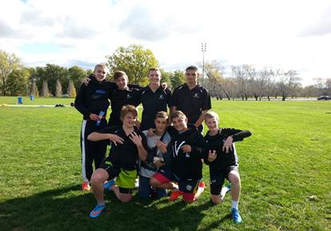

Wanniassa Senior Boys Southside Champions

**Cross Country Carnival**

On a blustery Tuesday afternoon the Senior Campus held its annual Cross Country Carnival. The whole school event saw our students take on either the 2km or 4km course as well as the elements. With each of the four houses (Gingera, Namadgi, Billy Billy and Tennent) competing for maximum points both through results and participation, the course allowed the students to take in the sights of the local community. Following the carnival and the free lunch kindly provided by Anytime Fitness, the students were given the opportunity to participate in a number of different activities in the afternoon that included Futsal and Table Tennis.

Although the weather was not kind it was fantastic to see so many of our dedicated students take on the challenge and literally put their best foot forward.

**Message from Anytime Fitness Chisholm and Lanyon**.

We would like to say a huge thank you to Wanniassa School for allowing us to be a part of your Cross Country Carnival. We are looking forward to being a part and helping out in any way we can in future events.

Although the weather didn’t permit us to run the activities we had planned, we did manage to put on a FREE sausage sizzle by Anytime Fitness Chisholm and Lanyon that was generously donated from Lanyon’s Local Butcher Marcus from M&K Meats, Baker’s Delight in Lanyon, and CJ Meats in the Chisholm Village. We can’t thank them enough for their support and contribution.

Anytime Fitness Chisholm and Lanyon are both community focused clubs and are always looking for ways we can give back to the community. We are very happy to announce to all parents and guardians who have children enrolled at Wanniassa that they are able to get started with a corporate deal until the end of June! For more information you can contact the Chisholm club on 6292 2846 / 0438 333 446 or the Lanyon club on 62847 227 / 0437 666 022.

**English/History/Japanese/Indigenous Programs**

Welcome back to Term 2!

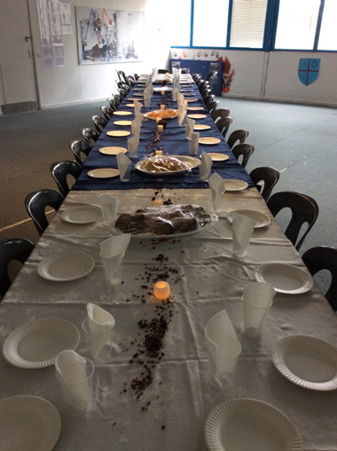

Year 8 had a fantastic end to Term 1’s study of Medieval Europe with their Medieval Day, including a lunch provided by the hospitality class, catapult building, dress ups and medieval games.

Thanks to Reece Cheater, Sally Hegh (History Teachers) and Emily Lord (Hospitality) for putting the day together.

Our Medieval Banquet Table

Welcome back to our Senior Campus Japanese teacher, Natalie Gastineau, returning from maternity leave. Japanese programs will re-commence soon.

This term we look forward to:

• Poetry in Action performance, 27 May

• History Competition, 27 May

• NAIDOC week activities and performance (Friday 26 June)

• Working with Chaydin Reid, Aboriginal dancer, in the 7/8 and 9/10 dance classes

Don’t forget that English students can gain extra credit toward their grade with the Wide Reading Program – see your English teacher for more details.

Cara Shipp - Executive Teacher English/History/Geography/Japanese and Indigenous Programs

# Whole School News

**Café Wanniassa**

Wanniassa Hospitality class prepares a restaurant function once a fortnight and I am pleased to announce this term we will be open to the public. I would like to invite any parents or carers, along with their guests who are interested to book a table by emailing a request to [Emily.mumberson@ed.act.edu.au](mailto:Emily.mumberson@ed.act.edu.au) . Restaurant service starts at 11:00am through to 11:45am on the following dates and usually includes a sit down two course menu.

|  |  |
| --- | --- |
| **Tuesday the 2nd June** | **Tuesday the 16th June** |
| Slow cooked lamb shanks with polenta.  or  Coq au vin with buttery mash potato. | Hoisin chicken stir-fry with rice.  or  Beef and black bean stir fry with rice. |
| Choc-orange croissant pudding with fresh custard. | White chocolate fondant with rhubarb coulis, served with cream. |

The cost of the above meals varies between $5 to $12. Please call the school closer to the restaurant date on 6205 6200 to confirm the menu pricing.

Emily Mumberson - Food Technology/Hospitality/Textiles Teacher

**Stranger Danger – Educate your children**

**A Message from ACT Policing**

ACT Policing is reminding parents to enforce the importance of stranger danger messages to their children following an incident in Conder last month (April), but also wants to assure the community that these events are rare and ‘not every white van is a concern’.

A student was walking home from Lanyon High School when she was approached by an unknown man on Box Hill Avenue in Conder.

The man approached the student and tried to engage her in conversation. The student became frightened and ran to a nearby oval adjacent to Charles Conder Primary School.

The man followed the student for a short distance before leaving the scene. The student was unharmed.

The man is described as Caucasian, about 5’7” (170cm) tall, around 30 years old with short dark hair. At the time he was wearing a grey and black flannelette shirt with dark track pants.

ACT Policing encourages parents to continue to educate their children in good personal safety practices including 'stranger danger' awareness and where possible, travelling in groups.

"This incident is a timely reminder to people to be mindful of their surroundings and to keep their level of awareness active regardless of what activities they are undertaking," Acting Superintendent Jo Cameron said.

Police however also want the community to be assured that these events are rare.

Over the past two years police have received some reports of children being approached by a man in a white van.

This has led to heightened public concern in regard to white vans around schools. Police encourage parents to talk to their children about this, but to keep things in perspective for their children, who should not become overly anxious when a white vehicle is seen near them or their school grounds.

“It’s important that just because a white van is seen around a school that the public does not immediately associate this with a possible abduction,” Acting Superintendent Cameron said.

“There are thousands of white vans that are driven around Canberra, many of which are owned by parents or tradespeople who are simply dropping their kids off to school.”

For more information on child safety and security, please visit the Constable Kenny Koala website at http://www.constablekenny.org.au/

**Maths Coach**

Innovative techniques applied to learning.

• Improved self-confidence and awareness

• Examination preparation

• Problem solving strategies

• Individual or small group

• 22 years industry experience

• Working with vulnerable people card

For a free prospective discussion please call Peter 0416 663 906

**Rhee Tae Kwon Do**

Rhee Tae Kwon Do is Australia’s first and largest Tae Kwon Do and has been in the Canberra region since 1970. Benefits include effective self-defence, fitness and good health, self-confidence, self-discipline and focus, family orientated. Our classes are held at Wanniassa School Senior Campus on Tuesdays and Thursdays 6:30 – 7:30 pm and are suitable for all ages from 8 year old up. For further information, call Alan on 6294 0591 in evenings or visit our website on www.rheeact.com.au .

P u b l i c E d u c a t i o n W e e k 2 0 1 5



P u b l i c E d u c a t i o n S h o w c a s e

10am—7pm Friday 22nd May, Tuggeranong Hyperdome

4.30pm Federal Member for Canberra, Gai Brodtmann MP

AEU ACT Branch Secretary, Glenn Fowler

We invite you to attend the public education school performances at the Tuggeranong Hyperdome, held to showcase the excellent work in public schools and to celebrate Public Education Week 2015.

h o w c a s i n g e x c e l l e n c e i n p u b l i c e d u c a t i o n



**Glenn Fowler—AEU ACT Branch Secretary**

Offices: 40 Brisbane Avenue BARTON ACT 2600 Postal Address: PO Box 3042 MANUKA ACT 2603

Telephone: 02 6272 7900 Fax: 02 6273 1828 [aeuact@aeuact.org.au](mailto:aeuact@aeuact.org.au) Website: [www.aeuact.org.au](http://www.aeuact.org.au/)

ABN No. 98 106 001 142

|  |
| --- |
|  |



**Invitation for Aboriginal & Torres Strait Islander students to participate in a special event:**

The Evonne Goolagong Foundation team are coming to Melba Tennis Club on WEDNESDAY 27 MAY 2015 from 10-2pm. This is a free event for all Indigenous students aged between 5 - 15yrs old.

Students are invited to attend this fun-filled day. The day includes tennis coaching, games on court and an inspirational talk from Evonne Goolagong.

Equipment and BBQ are all provided. Students must bring a hat and appropriate shoes.

If your student is interested, please contact me on [cara-jane.shipp@ed.act.edu.au](mailto:cara-jane.shipp@ed.act.edu.au) .

Cara Shipp - Executive Teacher English/History/Geography/Japanese and Indigenous Programs

|  |  |  |  |  |  |  |
| --- | --- | --- | --- | --- | --- | --- |
| |  |  |  |  |  |  | | --- | --- | --- | --- | --- | --- | | |  | | --- | | ACTION Bus Service Update Logo | | http://i.emlfiles1.com/cmpimg/t/s.gif | | **Reminder: Changes to ACTION School Services from** [**Monday 18 May 2015**](http://www.action.act.gov.au/news/news_articles/weekday-bus-timetable-adjustments-and-service-improvements-from-monday-18-may)    Following our notification to schools yesterday, we would like to advise that the upcoming changes were formally announced by Minister Rattenbury today, Thursday 2 April, and full details are now available on the [ACTION website.](http://www.action.act.gov.au/news/news_articles/weekday-bus-timetable-adjustments-and-service-improvements-from-monday-18-may)    Since the launch of the new schools network in September 2014, we have been continually monitoring the network using performance data and identifying areas for improvement. For dedicated school services these include:     * the addition of six new services * directional and stop changes for 21 school services * changed start times for 68 school services * and just 1 school service will no longer be in operation.     Other school services may have slight timing changes or no changes.    ACTION would appreciate your assistance in circulating this to assist schools, students and parents to plan travel from Monday 18 May. We encourage parents to also view the changes to the normal weekday network also taking effect on **Monday 18 May**, as connection times with dedicated school services may have changed.    For more information please visit [action.act.gov.au](http://www.action.act.gov.au/news/news_articles/weekday-bus-timetable-adjustments-and-service-improvements-from-monday-18-may) or call 13 17 10. | | ACTION Bus Logo |  |  | | --- | |  | | |